LSR A2 + HFW Reclaim

Pilot Study

PREPARED FOR

SG-DB-2338 – Exyte/Micron, Singapore

|  |  |  |  |
| --- | --- | --- | --- |
| **Date of Report** | **Revision History** | **Prepared By** | **Reviewed By** |
| 20/03/2024 | 0 | HJS |  |
| 27/03/2024 | 1 | HJS |  |

# Executive Summary

* 1. **Objective**

The objective of this pilot study is to evaluate the treatability and to optimize the process for the treatment scheme for combined feed of HFW A1+A2 and LSR A2 at the Micron Facility, Singapore. The expected deliverables are:

* Demonstration of the process at pilot scale prior to the actual implementation
* Confirmation of the quality of the treated water & recovery in compliance with the proposed specifications
  1. **Duration, facility and venue**
* The expected duration of the study is three months starting from Jan 2024 to March 2024.
* The study was carried out using ROI technology with **BW30 PRO-4040** membranes using the pilot unit housed in the Gradiant NPI facility.
  1. **Results summary**
* The treated water quality is found to be complied with the effluent quality specifications, with permeate fluoride = 6 mg/L (<15 mg/L) and permeate conductivity = 80 µS/cm (< 300 µS/cm).
* The RO recovery for the pilot study is ≥75%. However, with the current piping configuration and high-pressure pump, the on-site system will be operated at 60 – 75% recovery.
* The operating pressure for the ROI is around 12-13 bar.

Table of Contents

Executive Summary 2

List of Figures 4

List of Tables 4

Abbreviations 5

1 General Overview 6

1.1 Introduction 6

1.2 Objectives 6

2 Methodology 6

2.1 Overall Process Description 6

2.2 Sample Collection Points 7

2.3 Water Analysis 8

2.4 Evaluation of mixing ratio with bench test 8

2.5 RO Infinity (ROI) Experiments 9

2.6 Test Plan 13

3 Results AND DISCUSSIONS 13

3.1 Sample Collection Report 13

3.2 Preliminary operation – Run 1 and 2 13

3.3 Run 3 – Simulating site conditions 16

4 Conclusions and Recommendations 21

5 Appendix 22

Appendix A: Water Analysis of Raw Samples 22

Appendix B: Sample collection log 25

Appendix C: MSDS CURE-AS-9530 26

# List of Figures

Figure 1. Block diagram of treatment scheme 7

Figure 2: Case 3 Mixed Influent 7

Figure 3: Bench test on pH neutralization of LSR A2 and HFW A1+A2 samples. 9

Figure 4: ROI Pilot 10

Figure 5: The illustration of ROI testing system. 10

Figure 6: Sampling Log 13

Figure 7. (a) Feed pressure, (b) permeate flux and (c) reject conductivity for pilot study. 21

# List of Tables

Table 1: Sampling plan for actual pilot study. 8

Table 2: Equipment List 11

Table 3: Feed water analysis for preliminary Run 1 and 2 14

Table 4: Reject water analysis for preliminary Run 1 and 2. 14

Table 5: Permeate quality for preliminary Run 1 and 2. 15

Table 6. Result summary for pilot study 17

Table 7. Feed and reject water analysis for pilot study. 17

Table 8. Permeate water analysis for pilot study. 18

# Abbreviations

|  |  |
| --- | --- |
| **Abbreviation** | **Description** |
| IBC | Intermediate Bulk Container |
| IC | Ion Chromatography |
| ICP-OES | Inductively Coupled Plasma – Optical Emission Spectroscopy |
| RO | Reverse Osmosis |
| SBRO | Semi-batch reverse osmosis |
| ROI | RO Infinity |
| TDS | Total Dissolved Solids |
| TOC | Total Organic Carbon |
| TSS | Total suspended solids |

# General Overview

## 1.1 Introduction

Micron intends to reclaim HF wastewater in their LSR A2 system. The objective of this pilot study is to investigate the feasibility of reclaiming HFW wastewater without impacting LSR plant design capacity and treated water quality. The main deliverable of this study is to evaluate the maximum water that could be recovered and permeate quality generated.

## 1.2 Objectives

The pilot study was performed to:

* Confirm water analysis of the raw samples
* Confirm water analysis of the mixed sample
* Confirm final brine quality
* Check for any anomalies in water analysis such as high F, NO3, etc
* Calculate the optimal mixing ratios
* Calculate scaling potential
* Calculate maximum recovery that can be achieved
* Confirm ≥75% recovery and to recommend recovery range at the actual plant
* Confirm permeate water quality meets KPIs
* Confirm operating pressures and flow rates

# Methodology

## Overall Process Description

IBCs of wastewater were sent to Gradiant’s lab in Singapore. The IBCs were comprised of two different waste waters: LSR A2 and HFW A1+A2 and HFW Gravity Drain Chemical Room sample is contained in carboy.

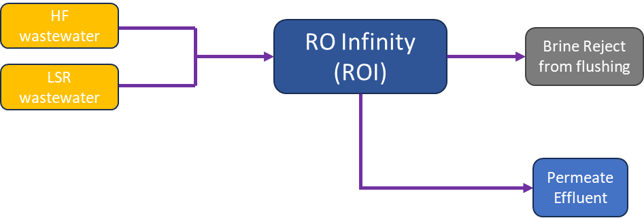

Figure 1. Block diagram of treatment scheme

LSR and HF wastewater will be combined according to a predetermined ratio (as stated in Figure 2). The wastewater was sent through the ROI membrane system to produce clean permeate, and a small amount of brine will be produced during the ROI service cycle and during the flushing cycle (Figure 1).

**Figure 2** shows the water quality of the mixed influent samples based on the Case 3 in the proposal.

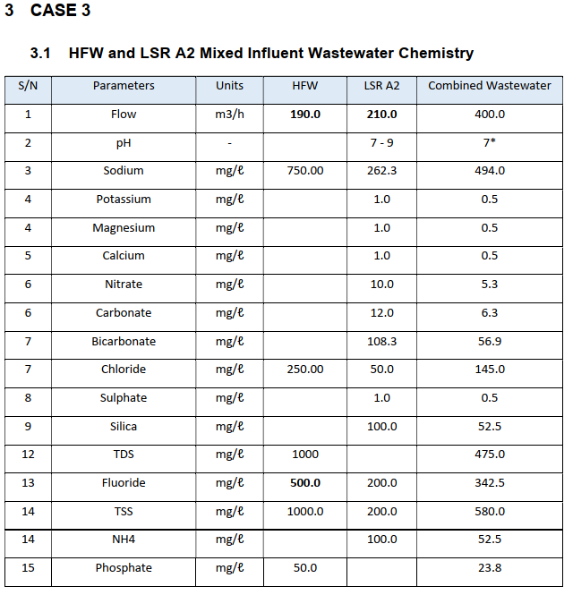

Figure 2: Case 3 Mixed Influent

## Sample Collection Points

Samples were collected at the following sampling points. The sampling plan is shown in Table 1.

1. HFW Gravity Drain A1 + HFW Gravity Drain A2
2. HFW Gravity Drain Chem Room
3. HFW Gravity Drain Gas Room†
4. LSR A2 Transfer pump

†HFW Gravity Drain Gas Room is not used in the experiment due to the low fluoride level which might dilute the feed.

Table 1: Sampling plan for actual pilot study.

|  |  |  |  |  |
| --- | --- | --- | --- | --- |
| **Sampling points** | **Volume (L)** | **Total volume (L)** | **Frequency in two days** | **Total quantity per tote (L)** |
| **HFW** | | | | |
| HFW Gravity Drain A1 | 175 | 250 | 4 | 1000  (1m3) |
| HFW Gravity Drain A2 | 75 |
| HFW Gravity Drain Chem Room | 5** | 5 | 20 |
| **LSR A2** | | | | |
| LSR A2 transfer pump | 250 | 250 | 4 | 1000  (1m3) |

**Collect in one 20 L carboys and mixing was done in GIH lab, LSR A1 feed is not required

Sample to be collected 2 times a day in 2 days.

Approximately 250 liters of each wastewater were collected into their respective IBC container each time. This was done once every 12 hour shift and collected over a period of 2 days.

The IBCs were sent to Gradiant Lab Facility after the sample collection was completed.

## Water Analysis

Samples that were received from the Micron Site were sent to Gradiant’s in-house lab for a full panel analysis. Feed composition was used to identify parameters of concern that may pose a risk to the project. The composition was also used for RO design projections and to estimate the maximum recovery achievable.

Gradiant’s dedicated laboratory for conducting the analysis for unknown substances in various industrial water and wastewater utilizes the below devices:

* Cations: Perkin Elmer Optima 8300 ICP-OES
* Anions: Metrohm 930 Compact IC
* TOC: Shimadzu TOC-L Analyzer
* General Analytes: Hach DR1900 Spectrophotometer

## Evaluation of mixing ratio with bench test

Samples in the respective IBC and carboy were analyzed for their composition to find out the mixing ratio (analysis is shown in Appendix A). The calculated mixing ratio was evaluated using a total volume of 800 mL and to find out the estimated volume of NaOH needed to neutralize the samples to pH ~7-8.

|  |  |
| --- | --- |
|  |  |

Figure 3: Bench test on pH neutralization of LSR A2 and HFW A1+A2 samples.

## RO Infinity (ROI) Experiments

The bench testing was performed using an ROI lab scale pilot plant pictured in **Figure 4**. In this setup, the wastewater was filtered and pumped from the feed tank to the ROI membrane module. The feed pressure was monitored using a pressure gauge. Flow was monitored using a combination of flowmeters, pH and conductivity measurements were taken using handheld instruments.

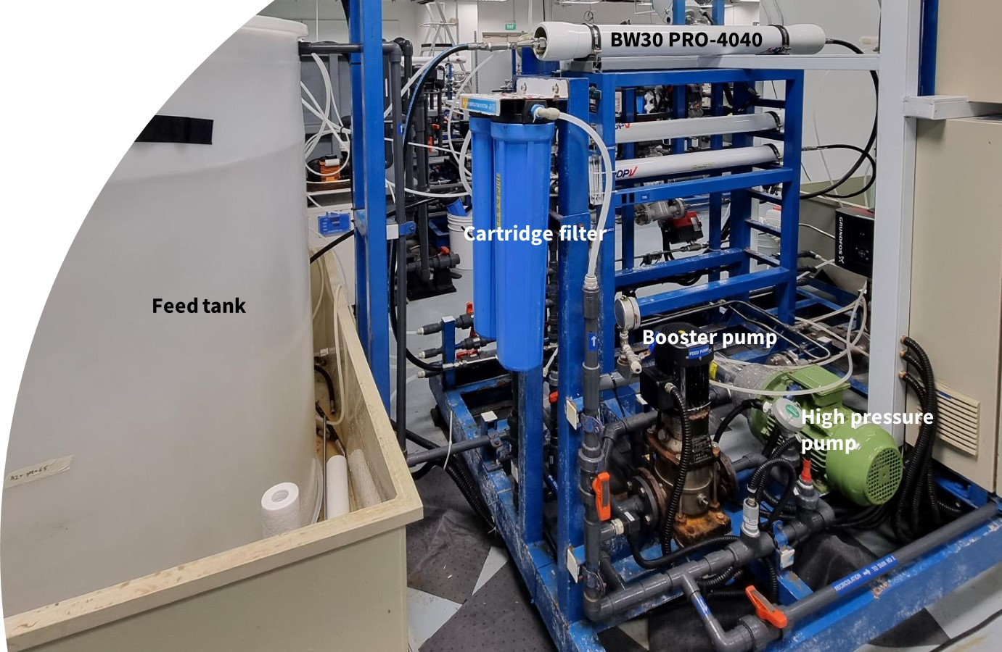

Figure 4: ROI Pilot

The 2D diagram is shown in **Figure 5**.

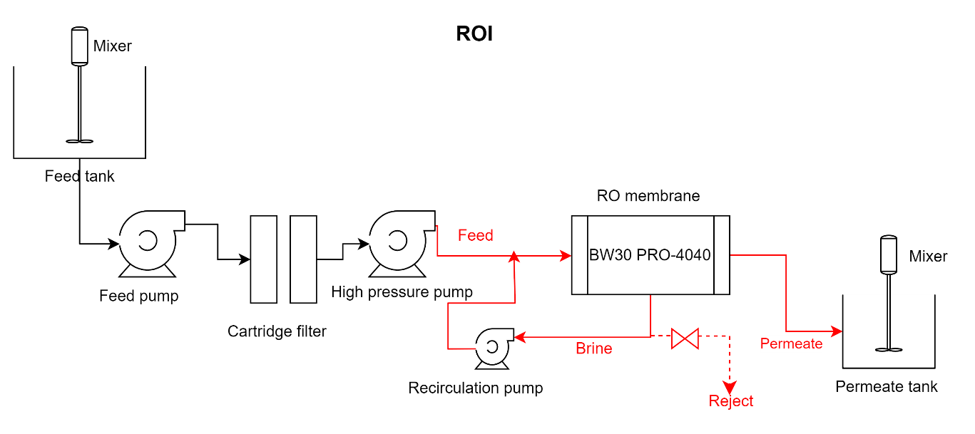

Figure 5: The illustration of ROI testing system.

Table 2: Equipment List

|  |  |  |  |
| --- | --- | --- | --- |
| **SN** | **Equipment Description** | **Size** | **Picture** |
| 1 | Feed Tank | 1500 L |  |
| 2 | Mixer | kW: 0.4  1420 rpm |  |
| 3 | Feed Pump | kW: 0.37 m3/h: 1.8 H/Hmax: 24.9/31.6m |  |
| 4 | Cartridge Filter | Polypropylene Spun  5 micron (nominal)  20-inch housing |  |
| 5 | High Pressure Pump | Max Outlet Pressure: 80 barg  Min Speed: 700 rpm  Max Speed: 3450 rpm  3450 rpm at max pressure: 5.5 kW  Max Flow: ~1.75m3/hr at 3450 rpm and 80 barg |  |
| 6 | Recirculation Pump | kW: 0.55  m3/h: 2.2  H/Hmax: 40.0/53.5m |  |
| 7 | Pressure Vessel | Qty 1  4040  Single Element |  |
| 8 | RO Membrane | **Filmtec™ BW30 PRO-4040 PILOT**  Active Area: 85 sqft (7.9 m2) Permeate Flow: 2600 gpd Min Rejection: 99.5% Length: 40” Diameter: 3.9” | DuPont-Filmtec BW30 PRO-4040 Fiberglassed Large Commercial Elements |

The CR100-4040 is a pilot element targeted for pilot testing while BW30 PRO-4040 is a commercial membrane. In this case, CR100 equivalent RO membranes, which is BW30 PRO-4040 was recommended by Dupont for this pilot unit testing. Both elements have similar membrane chemistry and salt rejection values. For the actual project on-site, 8-inch CR100 membranes will be used.

## Test Plan

The mixing ratio was determined by the bench test using small volume before running the semi-batch RO operations. LSR-IBC-001 and HFW-IBC-001 were combined according to the predetermined ratio. The combination is expected to prepare 1-2 m3 of feed water for this run. The ROI system was operated in a semi-batch mode until the feed tank has been depleted. The system was operated continuously for 2 hrs in this test.

The preliminary run 1 and 2 were trial operation to finetune the pilot ROI system and find out the permeate quality. Run 3 was the actual pilot operation to simulate the operating conditions at site and to investigate the suitable operating pressure at the given feed water quality.

# Results AND DISCUSSIONS

## Sample Collection Report

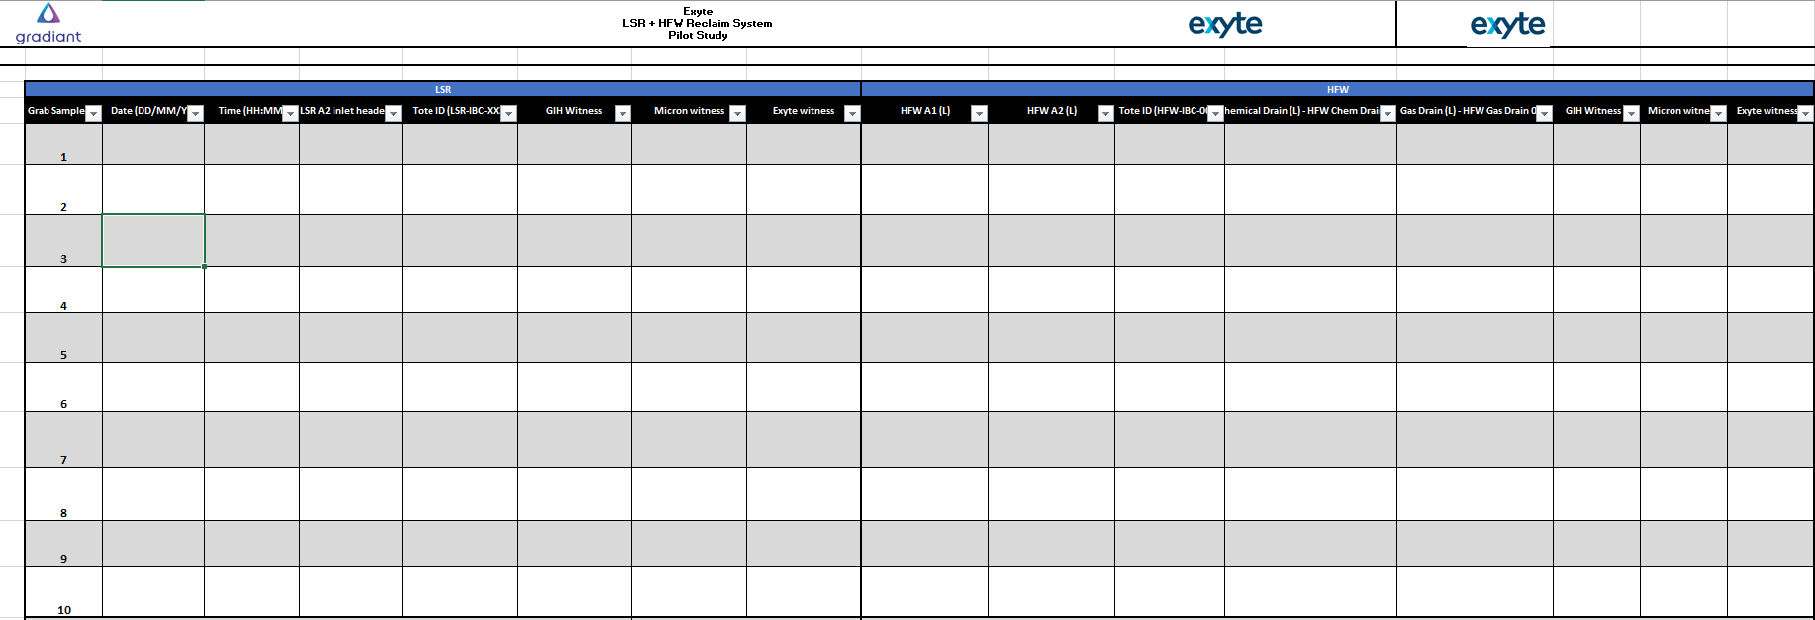

Figure 6: Sampling Log

Figure 6 shows the example of the sampling log and the actual sample collection logsheet is shown in Appendix C.

## Preliminary operation – Run 1 and 2

Both preliminary run 1 and 2 were carried out using the mixed samples of HFW A1+A2, LSR A2 and HFW Chemical Room in the ratio of 1:1:0.03. The measured fluoride for the mixture was found to be <350 mg/L and NaF was added to prepare the feed solution for both runs. Subsequently, 2 mg/L anti-scalant was added into the feed tank to prevent scaling from happening on the membrane surface. The permeate flow rate was maintained at 6 L/min (0.36 m3/h). The recovery was about 78% in this study. The SBRO service duration was kept at 15 mins and the flushing duration was maintained at 110 secs.

The feed water analysis for Run 1 and Run 2 is shown in Table 3 while the reject quality is shown in Table 4. Table 5 shows the permeate quality for Run 1 and 2. In summary, the permeate fluoride and other parameters are within the effluent specifications (Table 5).

Table 3: Feed water analysis for preliminary Run 1 and 2

|  |  |  |  |  |  |  |  |
| --- | --- | --- | --- | --- | --- | --- | --- |
| **S/N** | **Parameter** | **Unit** | **Run 1** | **Run 2 –**  **Day 1** | **Run 2 –**  **Day 2** | **Run 2 –**  **Day 3** | **Run 2 –**  **Day 4** |
| 1 | pH | - | 7.14 | 6.45 | 6.85 | 7.02 | 7.06 |
| 2 | Conductivity | µS/cm | 2310 | 2280 | 2130 | 2203 | 2200 |
| 3 | Alkalinity “M” as CaCO3 | mg/L | 28.0 | 28.5 | 37.0 | 30.0 | 30.0 |
| 4 | Alkalinity “P” as CaCO3 | mg/L | 0 | <2 | <2 | <2 | <2 |
| 5 | Fluoride as F | mg/L | 366.0 | 409 | 353.5 | 381 | 403 |
| 6 | Chloride as Cl | mg/L | 24.2 | 15.5 | 11.0 | 19.3 | 13.2 |
| 7 | Nitrate as NO3 | mg/L | 153.0 | 167 | 100.5 | 91.2 | 109 |
| 8 | Ammonia as NH3-N | mg/L | 13.6 | 16.0 | 10.2 | <0.4 | 0.4 |
| 9 | Calcium as Ca | mg/L | 0.47 | 0.315 | <0.1 | 0.127 | 0.117 |
| 10 | Total Silica SiO2 | mg/L | 15.4 | 19.8 | 20.5 | 21.6 | 28.5 |
| 11 | Reactive silica as SiO2 | mg/L | 16.6 | 20.4 | 21.3 | 22.9 | 28.1 |
| 12 | TDS | mg/L | 1136 | 1145 | 1047 | 1106 | 1114 |
| 13 | Turbidity | NTU | 1.19 | 0.791 | 0.695 | 1.44 | 0.57 |
| 14 | TSS | mg/L | 8 | 9 | <3 | <3 | <3 |
| 15 | TOC | mg/L | 18.5 | 6.43 | 15.1 | 14.5 | 15.1 |

Table 4: Reject water analysis for preliminary Run 1 and 2.

|  |  |  |  |  |  |  |  |
| --- | --- | --- | --- | --- | --- | --- | --- |
| **S/N** | **Parameter** | **Unit** | **Run 1** | **Run 2 –**  **Day 1** | **Run 2 –**  **Day 2** | **Run 2 –**  **Day 3** | **Run 2 –**  **Day 4** |
| 1 | pH | - | 7.26 | 6.81 | 7.35 | 7.01 | 7.12 |
| 2 | Conductivity | µS/cm | 7380 | 7450 | 7450 | 7493 | 7255 |
| 3 | Alkalinity “M” as CaCO3 | mg/L | 129.6 | 124 | 144 | 138 | 140 |
| 4 | Alkalinity “P” as CaCO3 | mg/L | 0 | <2 | <2 | <2 | <2 |
| 5 | Fluoride as F | mg/L | 1307 | 1247 | 1379 | 1302 | 1330 |
| 6 | Chloride as Cl | mg/L | 64.0 | 60.4 | 41.2 | 79.9 | 53.1 |
| 7 | Nitrate as NO3 | mg/L | 507 | 519.6 | 348 | 289.1 | 387 |
| 8 | Ammonia as NH3-N | mg/L | 0.39 | 47.8 | <0.4 | 65.0 | 53.1 |
| 9 | Calcium as Ca | mg/L | 1.43 | <0.1 | <0.1 | <0.1 | 0.477 |
| 10 | Total Silica SiO2 | mg/L | 55.1 | 61.6 | 104 | 105 | 101.9 |
| 11 | Reactive silica as SiO2 | mg/L | 57.5 | 68.4 | 104 | 107 | 105 |
| 12 | TDS | mg/L | 3976 | 4105 | 3923 | 4002 | 4016 |
| 13 | Turbidity | NTU | 4.02 | 3.92 | 2.58 | 0.243 | 0.416 |
| 14 | TSS | mg/L | 53.0 | 7 | <3 | <3 | <3 |
| 15 | TOC | mg/L | 57.0 | 42.5 | 48.5 | 49.2 | 47.4 |

Table 5: Permeate quality for preliminary Run 1 and 2.

|  |  |  |  |  |  |  |  |  |
| --- | --- | --- | --- | --- | --- | --- | --- | --- |
| **S/N** | **Parameters** | **Unit** | **Specs** | **Run 1** | **Run 2 – Day 1** | **Run 2 – Day 2** | **Run 2 – Day 3** | **Run 2 – Day 4** |
| 1 | Conductivity | μS/cm | 5-300 | 82.4 | 82.0 | 53.2 | 62.9 | 65.2 |
| 2 | Total Suspended Solid (TSS) | mg/L | <100 | 3 | <3 | <3 | <3 | <3 |
| 3 | pH |  | 7-9 | 6.46† | 5.6† | 6.65† | 7.42 | 7.35 |
| 4 | Aluminium (Al) | mg/L | 0.2 | <0.1 | <0.1 | <0.1 | <0.1 | <0.1 |
| 5 | Antimony (Sb) | mg/L | 0.005 | <0.1 | <0.1 | <0.1 | <0.1 | <0.1 |
| 6 | Arsenic (As) | mg/L | 0.01 | <0.1 | <0.1 | <0.1 | <0.1 | <0.1 |
| 7 | Barium (Ba) | mg/L | 0.1 | <0.1 | <0.1 | <0.1 | <0.1 | <0.1 |
| 8 | Beryllium (Be) | mg/L | 0.1 | <0.1 | <0.1 | <0.1 | <0.1 | <0.1 |
| 9 | Bismuth (Bi) | mg/L | 0.1 | <0.1 | <0.1 | <0.1 | <0.1 | <0.1 |
| 10 | Boron (B) | mg/L | 1 | 0.53 | 0.382 | 0.271 | 0.298 | <0.1 |
| 11 | Calcium (Ca) | mg/L | 3 | <0.1 | <0.1 | <0.1 | <0.1 | <0.1 |
| 12 | Chromium (Cr) | mg/L | 0.05 | <0.1 | <0.1 | <0.1 | <0.1 | <0.1 |
| 13 | Chloride (Cl) | mg/L | 50 | 2.87 | 1.36 | 1.32 | 1.442 | 2.51 |
| 14 | Cobalt (Co) | mg/L | 1 | <0.1 | <0.1 | <0.1 | <0.1 | <0.1 |
| 15 | Copper (Cu) | mg/L | 2 | <0.1 | <0.1 | <0.1 | <0.1 | <0.1 |
| 16 | Fluoride (F) | mg/L | 15 | 8.0 | 9.27 | 6.30 | 7.42 | 6.71 |
| 17 | Free Chlorine | mg/L | 0.3 | 0.03 | 0.03 | 0.05 | 0.02 | 0.02 |
| 18 | Gallium (Ga) | mg/L | 0.2 | <0.1 | <0.1 | <0.1 | <0.1 | <0.1 |
| 19 | Iron (Fe) | mg/L | 0.3 | <0.1 | <0.1 | <0.1 | <0.1 | <0.1 |
| 20 | Lead (Pb) | mg/L | 0.01 | <0.1 | <0.1 | <0.1 | <0.1 | <0.1 |
| 21 | Lithium (Li) | mg/L | 1 | <0.1 | <0.1 | <0.1 | <0.1 | <0.1 |
| 22 | Magnesium (Mg) | mg/L | 3 | <0.1 | <0.1 | <0.1 | <0.1 | <0.1 |
| 23 | Manganese (Mn) | mg/L | 0.1 | <0.1 | <0.1 | <0.1 | <0.1 | <0.1 |
| 24 | Molybdenum (Mo) | mg/L | 0.1 | <0.1 | <0.1 | <0.1 | <0.1 | <0.1 |
| 25 | Nickel (Ni) | mg/L | 0.02 | <0.1 | <0.1 | <0.1 | <0.1 | <0.1 |
| 26 | Potassium (K) | mg/L | 5 | 0.422 | 0.175 | 0.243 | 0.271 | <0.1 |
| 27 | Silica as Si | mg/L | 30 | <0.1 | <0.1 | <0.1 | 0.237 | <0.1 |
| 28 | Sodium (Na) | mg/L | 50 | 11.5 | 11.00 | 8.11 | 8.67 | 12.31 |
| 29 | Strontium (Sr) | mg/L | 3 | <0.1 | <0.1 | <0.1 | <0.1 | <0.1 |
| 30 | Sulphate (SO4) | mg/L | 50 | 1.4 | <0.1 | 0.145 | 0.146 | <0.1 |
| 31 | Thallium (Tl) | mg/L | 0.01 | <0.1 | <0.1 | <0.1 | <0.1 | <0.1 |
| 32 | Titanium (Ti) | mg/L | 0.1 | <0.1 | <0.1 | <0.1 | <0.1 | <0.1 |
| 33 | TOC | mg/L | 3 | 3.14 | 3.02 | 3.00 | 3.13 | 3.1 |
| 34 | Zinc (Zn) | mg/L | 3 | <0.1 | <0.1 | <0.1 | <0.1 | <0.1 |
| 35 | Total Hardness | mg/L | 1 | <0.1 | <0.1 | <0.1 | <0.1 | <0.1 |

†The experiment was carried out without pH adjustment at the effluent. However, NaOH dosing will be done on-site to adjust the pH to within specifications.

## Run 3 – Simulating site conditions

Run 3 was operated based on the site conditions to simulate the actual operations as much as possible. This run was carried out using the mixed samples of HFW A1+A2, LSR A2 and HFW Chemical Room in the ratio of 1:1:0.03 (according to Case 3 in Figure 2). The measured combined feed fluoride was found to be 211 mg/L and 443 g NaF was added to prepare the solution for this operation. Subsequently, 2 mg/L anti-scalant was added into the feed tank to prevent scaling from happening on the membrane surface. The anti-scalant follows the same dosage as the site-operation for this pilot study. Site operating condition, for example, the permeate flux was simulated in this run to investigate the appropriate operating pressure on-site. The service duration of the ROI is maintained at 15 mins and the flushing duration is lasted for 110 sec. A RO feed pressure range of 12 – 13 bar is shown in Figure 7a, these recorded pressure range is within the operating pressure range of the high pressure RO pump on-site. A slightly higher pressure in the operation as compared to the projection could be due to the system piping configuration which projection does not consider this aspect. The permeate flux of the pilot ROI operation is shown in Figure 7b and it was maintained at 22 LMH. The slight spike in the permeate flux was due to the start-up of the system and the pressure of the pilot setup was controlled using manual valve which might result in slight inconsistency. Figure 7c shows the reject conductivity for the ROI operation, the maximum reject conductivity in this study is around ~ 9900 µS/cm. This result serves as the reference range for the reject conductivity setpoints for the ROI operation during commissioning. On the other hand, an alternative anti-scalant, CURE-AS-9530 (refer to Appendix C for MSDS) is proposed for the on-site operation as it demonstrates similar performance in terms of scaling prevention and it is more cost effective.

Table 6 shows the result summary for preliminary run 1 and 2 as well as the actual operation - run 3. The relationships of feed pH and feed nitrate vs fluoride rejection are shown in Figure A1 and Figure A2. The linear correlation of feed nitrate and fluoride rejection shows a higher R2 values than feed pH vs fluoride rejection. The permeate fluoride for all the operations is <15 mg/L, indicating that LSR system is able to treat the high fluoride water from HFW. All the operations in the pilot study were carried out with recovery >75%, however, with the current piping configuration and high-pressure pump, the expected recovery in actual operation at site will be in the range of t 60 – 75% recovery. The detailed analysis of feed, reject and permeate of Run 3 is displayed in Table 7 and Table 8.

Table 6. Result summary for pilot study-Run 3

|  |  |  |  |  |  |  |  |
| --- | --- | --- | --- | --- | --- | --- | --- |
| Date | Operation | Recovery (%) | Feed pH | Feed fluoride (mg/L) | Permeate fluoride (mg/L) | Fluoride rejection (%) | Feed nitrate (mg/L) |
| 2 Feb 24 | Run 1 | 78.0 | 7.14 | 366.0 | 8.00 | 97.8 | 153.0 |
| 20 Feb 24 | Run 2- Day 1 | 78.6 | 6.45 | 409.0 | 9.27 | 97.7 | 167.0 |
| 21 Feb 24 | Run 2 – Day 2 | 77.0 | 6.85 | 353.5 | 6.30 | 98.2 | 100.5 |
| 22 Feb 24 | Run 2 – Day 3 | 77.1 | 7.02 | 381.0 | 7.42 | 98.1 | 91.2 |
| 23 Feb 24 | Run 2 – Day 4 | 75.5 | 7.06 | 403.0 | 6.71 | 98.3 | 109.0 |
| 13 Mar 24 | Run 3 | 78.4 | 8.6 | 372 | 5.95 | 98.4 | 93.9 |

Table 7. Feed and reject water analysis for pilot study-Run 3

|  |  |  |  |  |
| --- | --- | --- | --- | --- |
| **S/N** | **Parameter** | **Unit** | **Feed** | **Reject** |
| 1 | pH | - | 8.6 | 7.85 |
| 2 | Temperature | °C | 23.0 | 23.1 |
| 3 | Conductivity | µS/cm | 2270 | 9604 |
| 4 | Alkalinity “M” as CaCO3 | mg/L | 74.0 | 284 |
| 5 | Alkalinity “P” as CaCO3 | mg/L | <2 | <2 |
| 6 | Fluoride as F | mg/L | 372 | 1736 |
| 7 | Chloride as Cl | mg/L | 26.9 | 100 |
| 8 | Nitrate as NO3 | mg/L | 93.9 | 444 |
| 9 | Ammonia as NH3-N | mg/L | 17.2 | 66.6 |
| 10 | Calcium as Ca | mg/L | 0.842 | 1.49 |
| 11 | Total Silica SiO2 | mg/L | 25.2 | 114 |
| 12 | Reactive silica as SiO2 | mg/L | 24.1 | 94.5 |
| 13 | TDS | mg/L | 1079 | 4905 |
| 14 | Turbidity | NTU | 5.37 | 4.98 |
| 15 | TSS | mg/L | 8 | 4 |
| 16 | TOC | mg/L | 13 | 47.3 |

Table 8. Permeate water analysis for pilot study-Run 3

|  |  |  |  |  |
| --- | --- | --- | --- | --- |
| **S/N** | **Parameters** | **Unit** | **Specs** | **Permeate** |
| 1 | Conductivity | μS/cm | 5-300 | 80.0 |
| 2 | Total Suspended Solid (TSS) | mg/L | <100 | <3 |
| 3 | pH |  | 7-9 | 9.39† |
| 4 | Aluminium (Al) | mg/L | 0.2 | <0.1 |
| 5 | Antimony (Sb) | mg/L | 0.005 | <0.1‡ |
| 6 | Arsenic (As) | mg/L | 0.01 | <0.1‡ |
| 7 | Barium (Ba) | mg/L | 0.1 | <0.1 |
| 8 | Beryllium (Be) | mg/L | 0.1 | <0.1 |
| 9 | Bismuth (Bi) | mg/L | 0.1 | <0.1 |
| 10 | Boron (B) | mg/L | 1 | 0.635 |
| 11 | Calcium (Ca) | mg/L | 3 | <0.1 |
| 12 | Chromium (Cr) | mg/L | 0.05 | <0.1‡ |
| 13 | Chloride (Cl) | mg/L | 50 | 1.53 |
| 14 | Cobalt (Co) | mg/L | 1 | <0.1 |
| 15 | Copper (Cu) | mg/L | 2 | <0.1 |
| 16 | Fluoride (F) | mg/L | 15 | 5.95 |
| 17 | Gallium (Ga) | mg/L | 0.2 | <0.1 |
| 18 | Iron (Fe) | mg/L | 0.3 | <0.1 |
| 19 | Lead (Pb) | mg/L | 0.01 | <0.1‡ |
| 20 | Lithium (Li) | mg/L | 1 | <0.1 |
| 21 | Magnesium (Mg) | mg/L | 3 | <0.1 |
| 22 | Manganese (Mn) | mg/L | 0.1 | <0.1 |
| 23 | Molybdenum (Mo) | mg/L | 0.1 | <0.1 |
| 24 | Nickel (Ni) | mg/L | 0.02 | <0.1 |
| 25 | Potassium (K) | mg/L | 5 | <0.1 |
| 26 | Silica as Si | mg/L | 30 | <0.1 |
| 27 | Sodium (Na) | mg/L | 50 | 16.3 |
| 28 | Strontium (Sr) | mg/L | 3 | <0.1 |
| 29 | Sulphate (SO4) | mg/L | 50 | 0.129 |
| 30 | Thallium (Tl) | mg/L | 0.01 | <0.1‡ |
| 31 | Titanium (Ti) | mg/L | 0.1 | <0.1 |
| 32 | TOC | mg/L | 3 | 2.99 |
| 33 | Zinc (Zn) | mg/L | 3 | <0.1 |
| 34 | Total Hardness | mg/L | 1 | <0.1 |

†pH is higher than 9 because there is no pH adjustment done in the effluent of pilot study. pH adjustment will be done on-site.

‡The detection limit of ICP-OES for metal detection is at 0.1 mg/L.

(a)

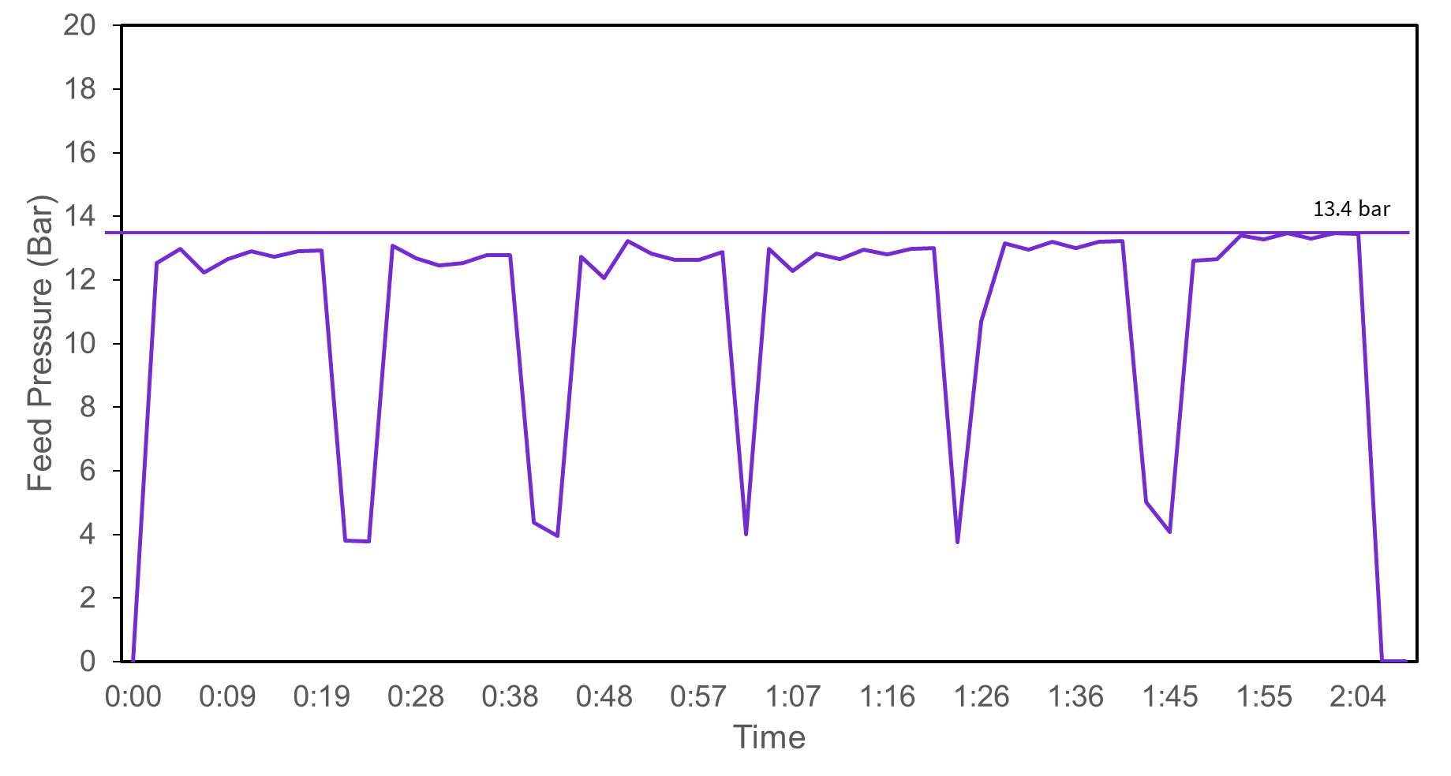

(b)

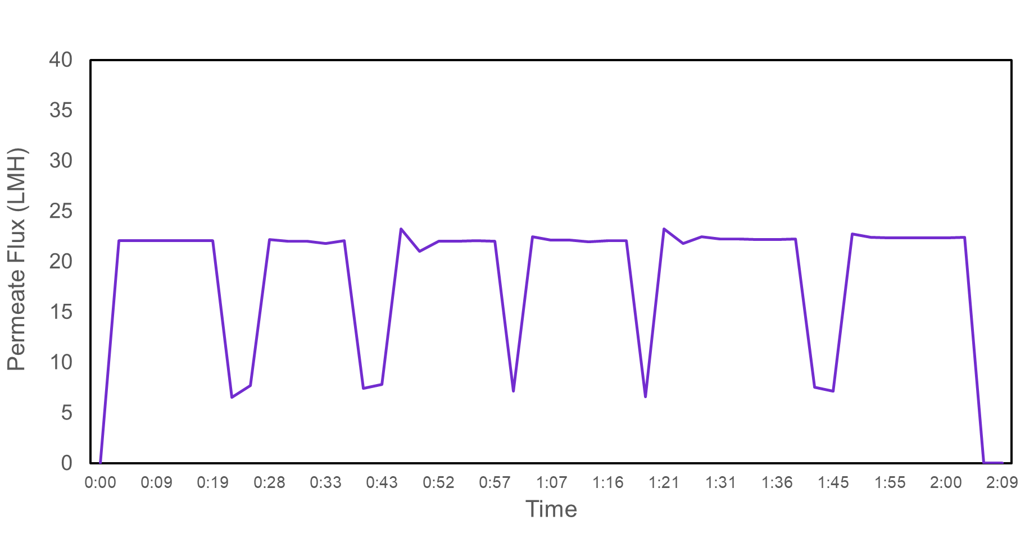

(c)

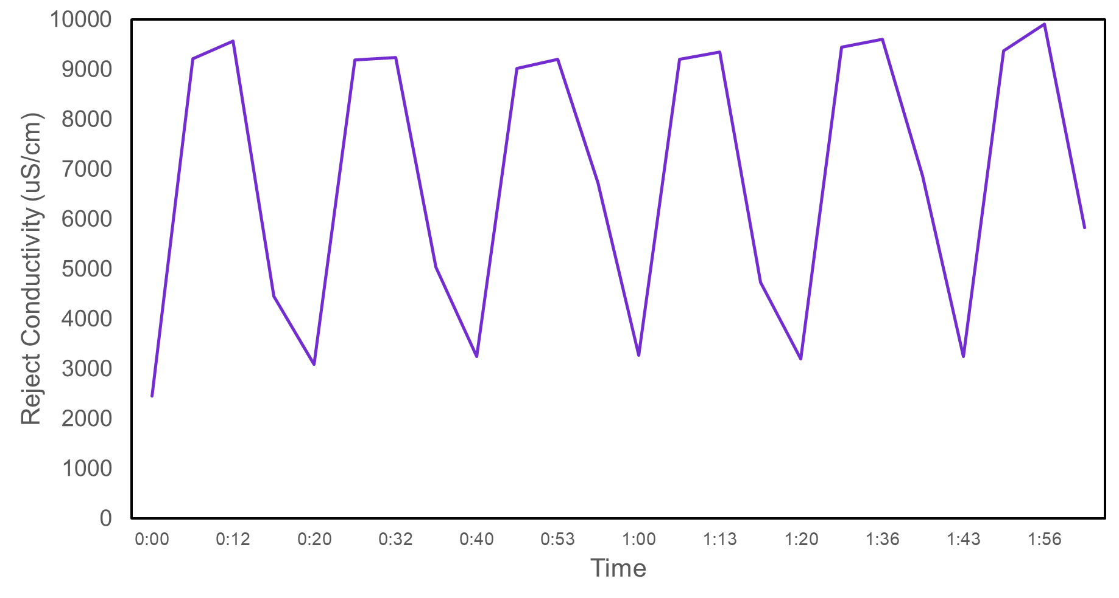

Figure 7. (a) Feed pressure, (b) permeate flux and (c) reject conductivity for pilot study.

# Conclusions and Recommendations

The pilot study demonstrates that the ROI system is able to treat the incoming high fluoride content water (~350 mg/L) with 1:1 mixing ratio of HFW A1 +A2 and LSR A2. Based on the water analysis results obtained from the lab, the mixture of HFW and LSR wastewater is always lesser than 350 mg/L and NaF was spiked into the feed water to obtain the required fluoride level. The ROI experiment was operated at ≥75% recovery. However, with the current piping configuration and high-pressure pump, the on-site system will be operated at 60 – 75% recovery. The permeate fluoride level was maintained at <15 mg/L in all cases. The suggested operating pressure for the ROI system on-site is within the range of 12-13 bar based on the pilot system. The maximum reject fluoride is ~1736 mg/L (based on run 3 result), which will be discharged into the HFW system as ROI reject intermittently during the flushing cycle. Due to the higher conductivity/TDS in the brine of ROI system, a more frequent CIP of once every 30 days is anticipated for the LSR + HFW system on-site. The results from this pilot study serve as the basis for the HFW reclaim + LSR A2 operating parameters, however, the actual ROI operating conditions on-site will be fine-tuned during the commissioning and long term impact on ROI membrane will be investigated during the operation phase.

# Appendix

## Appendix A: Water Analysis of Raw Samples

Table A1. HFW A1+A2 Water Analysis.

|  |  |  |  |  |  |  |  |  |
| --- | --- | --- | --- | --- | --- | --- | --- | --- |
| **S/N** | **Parameter** | **Unit** | **Run 1**  **IBC 1**  **30 Jan 24** | **Run 2 – Day 1 6 Feb 24** | **Run 2 – Day 2**  **6 Feb 24** | **Run 2 – Day 3**  **6 Feb 24** | **Run 2 – Day 4**  **6 Feb 24** | **Run 3 IBC 1**  **11 Mar 24** |
| 1 | pH | - | 3.48 | 3.57 | 3.57 | 3.80 | 3.71 | 3.04 |
| 2 | Temperature | °C | 22.2 | 22.2 | 22.2 | 22.2 | 22.2 | 23.0 |
| 3 | Conductivity | µS/cm | 1738 | 1851 | 1575 | 1595 | 1632 | 1804 |
| 4 | Alkalinity “M” as CaCO3 | mg/L | NA* | NA* | NA* | NA* | NA* | NA* |
| 5 | Alkalinity “P” as CaCO3 | mg/L | NA* | NA* | NA* | NA* | NA* | NA* |
| 6 | Fluoride as F | mg/L | 402 | 402 | 400 | 427 | 427 | 383 |
| 7 | Chloride as Cl | mg/L | 21.5 | 11.7 | 7.6 | 21.8 | 11.5 | 19.0 |
| 8 | Nitrate as NO3 | mg/L | 243.6 | 305 | 148 | 146 | 176 | 175 |
| 9 | Ammonia as NH3-N | mg/L | 10.5 | <0.4 | 2.5 | 5.8 | <0.4 | 4.7 |
| 10 | Calcium as Ca | mg/L | <1 | <1 | <1 | <1 | <1 | 1.35 |
| 11 | Total Silica SiO2 | mg/L | 14.7 | 14.9 | 22.9 | 24.8 | 28.5 | 18.0 |
| 12 | TDS | mg/L | 644 | 776 | 561 | 816 | 728 | 723 |
| 13 | Turbidity | NTU | 159 | 178 | 162 | 197 | 153 | 247 |
| 14 | TSS | mg/L | 14 | 94 | 41 | 53 | 40 | 80 |
| 15 | TOC | mg/L | 25.7 | 23.8 | 22.8 | 22.9 | 25.2 | 22.6 |

*Carbonate & Bicarbonate NA due to pH<8.3 and pH<4.5 respectively.

Table A2. HFW Chemical Room Water Analysis

|  |  |  |  |  |  |  |  |  |
| --- | --- | --- | --- | --- | --- | --- | --- | --- |
| **S/N** | **Parameter** | **Unit** | **Run 1**  **IBC 1**  **30 Jan 24** | **Run 2 – Day 1 6 Feb 24** | **Run 2 – Day 2**  **6 Feb 24** | **Run 2 – Day 3**  **6 Feb 24** | **Run 2 – Day 4**  **6 Feb 24** | **Run 3 IBC 1**  **11 Mar 24** |
| 1 | pH | - | 2.71 | 8.19 | 7.98 | 7.12 | 7.12 | 2.78 |
| 2 | Temperature | °C | 22.1 | 22.2 | 22.2 | 22.2 | 22.2 | 23.0 |
| 3 | Conductivity | µS/cm | 7500 | 27600 | 4690 | 3650 | 8490 | 2048 |
| 4 | Alkalinity “M” as CaCO3 | mg/L | NA* | 588 | 72 | 36 | 56 | NA* |
| 5 | Alkalinity “P” as CaCO3 | mg/L | NA* | <2 | <2 | <2 | <2 | NA* |
| 6 | Fluoride as F | mg/L | 4358 | 6991 | 769 | 567 | 1411 | 511 |
| 7 | Chloride as Cl | mg/L | 18.5 | 30.3 | 33.6 | 39.5 | 28.3 | 27.2 |
| 8 | Nitrate as NO3 | mg/L | 401.5 | 38.8 | 577 | 375 | 1145.7 | 145 |
| 9 | Ammonia as NH3-N | mg/L | 4.1 | 86.0 | 5.4 | 30.4 | 5.3 | 7.1 |
| 10 | Calcium as Ca | mg/L | <1 | 2.01 | 2.02 | 2.01 | 2.01 | 0.174 |
| 11 | Total Silica SiO2 | mg/L | 40.6 | 59.5 | 70.3 | 38.1 | 31.4 | 18.0 |
| 13 | TDS | mg/L | 3750 | 10610 | 2850 | 2224 | 5143 | 456 |
| 14 | Turbidity | NTU | 59.2 | 10.9 | 7.29 | 0.312 | 0.164 | 233 |
| 15 | TSS | mg/L | 7 | <3 | 8 | <3 | <3 | 63 |
| 16 | TOC | mg/L | 9.64 | 13.83 | 44.51 | 56.55 | 20.88 | 27.1 |

*Carbonate & Bicarbonate NA due to pH<8.3 and pH<4.5 respectively.

Table A3. LSR A2 Water Analysis

|  |  |  |  |  |  |  |  |  |
| --- | --- | --- | --- | --- | --- | --- | --- | --- |
| **S/N** | **Parameter** | **Unit** | **Run 1**  **IBC 1**  **30 Jan 24** | **Run 2 – Day 1 6 Feb 24** | **Run 2 – Day 2**  **6 Feb 24** | **Run 2 – Day 3**  **6 Feb 24** | **Run 2 – Day 4**  **6 Feb 24** | **Run 3 IBC 1**  **11 Mar 24** |
| 1 | pH | - | 3.93 | 3.78 | 3.83 | 3.87 | 3.83 | 3.58 |
| 2 | Temperature | °C | 22.2 | 22.2 | 22.2 | 22.2 | 22.2 | 23.0 |
| 3 | Conductivity | µS/cm | 354 | 424 | 358 | 424 | 423 | 449 |
| 4 | Alkalinity “M” as CaCO3 | mg/L | NA* | NA* | NA* | NA* | NA* | NA* |
| 5 | Alkalinity “P” as CaCO3 | mg/L | NA* | NA* | NA* | NA* | NA* | NA* |
| 6 | Fluoride as F | mg/L | 64 | 59 | 51 | 64 | 68 | 62.8 |
| 7 | Chloride as Cl | mg/L | 11.1 | 36.4 | 33.3 | 16.6 | 13.6 | 20.2 |
| 8 | Nitrate as NO3 | mg/L | 2.00 | 2.49 | 2.33 | 2.56 | 2.55 | 1.34 |
| 9 | Ammonia as NH3-N | mg/L | 18.0 | 14.8 | 16.5 | 27.2 | 26.0 | 25.3 |
| 10 | Calcium as Ca | mg/L | <1 | <1 | <1 | <1 | <1 | <1 |
| 11 | Total Silica SiO2 | mg/L | 19.4 | 26.3 | 18.5 | 25.8 | 32.4 | 24.6 |
| 12 | TDS | mg/L | 97 | 111 | 84 | 91 | 70 | 77 |
| 13 | Turbidity | NTU | 0.752 | 0.136 | 0.314 | 0.231 | 0.2 | 0.719 |
| 14 | TSS | mg/L | <3 | <3 | <3 | <3 | <3 | 7 |
| 15 | TOC | mg/L | 7.35 | 1.64 | 1.39 | 1.84 | 1.57 | 2.19 |

*Carbonate & Bicarbonate NA due to pH<8.3 and pH<4.5 respectively.

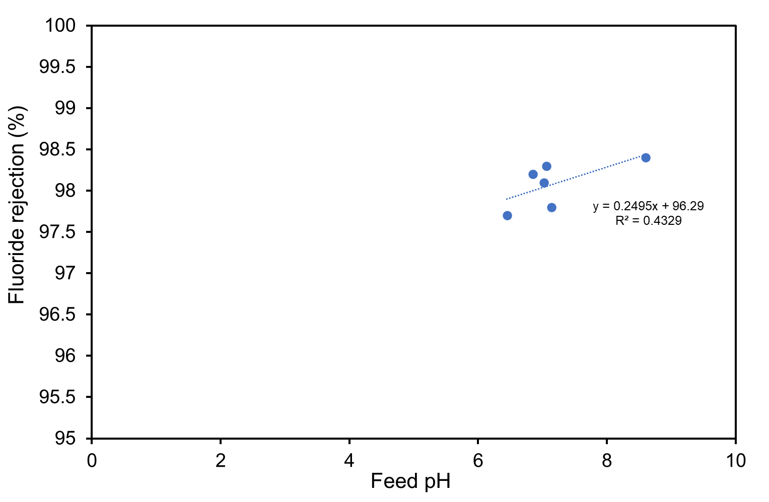

Figure A1. Relationship between feed pH and fluoride rejection.

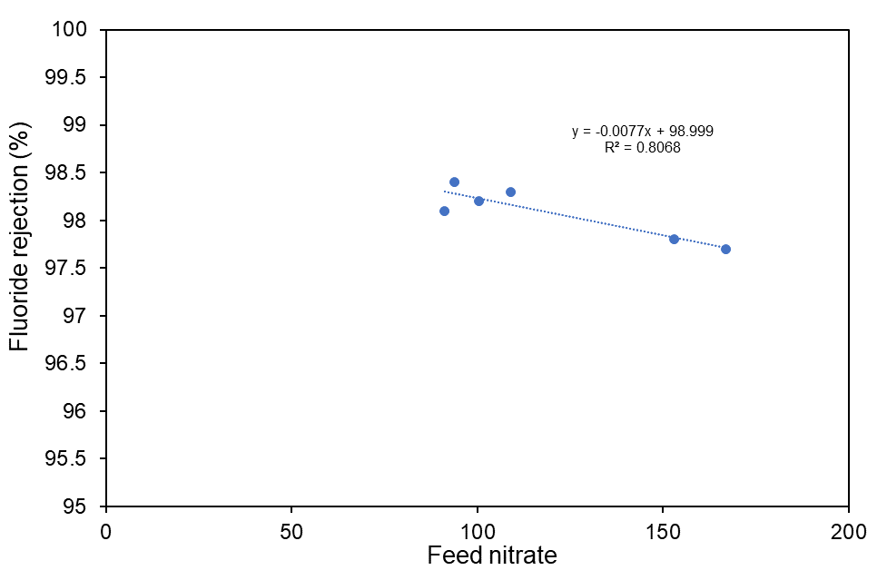

Figure A2. Relationship between feed nitrate and fluoride rejection.

## Appendix B: Sample collection log

## Appendix C: MSDS CURE-AS-9530

